Staff Management System

BONIC OCHARO

COM/0049/20

A System Proposal Submitted in Partial Fulfillment of the Requirements for the Award of Bachelor’s Degree in Computer Science of Kibabii University

April, 2025
DECLARATION
This project proposal is my original work prepared with no other than the indicated sources and support and has not been presented elsewhere for a degree or any other award.

_____________________ ______________________________

BONIC OCHARO Date
COM/0049/20

APPROVAL
The undersigned certify that they have read and hereby recommend for the acceptance of Kibabii University a proposal entitled Staff Management System

______________ ______________________________
DR. Etene Date
Department of Computer Science
Kibabii University

ABSTRACT
The proliferation of Internet of Things (IoT) technology has revolutionized home security systems, with smart doorbells emerging as a critical component of modern residential protection. This project presents the design, development, and implementation of an IoT-based Smart Doorbell System with Mobile Application Integration, focusing on real-time monitoring, remote access, and enhanced security features. The system comprises a hardware doorbell unit equipped with a high-definition camera, motion sensors, and two-way audio, paired with a cross-platform mobile application for user interaction.

Key functionalities include live video streaming, motion-triggered alerts, cloud-based video storage, and smart home integration. The doorbell connects via Wi-Fi to a centralized cloud server, enabling secure data transmission to the mobile app. Advanced features such as facial recognition, night vision mode, and geofencing further enhance usability and security. The accompanying mobile application, developed for both iOS and Android platforms, provides an intuitive user interface for managing alerts, reviewing recorded footage, and customizing settings.

Security measures were prioritized throughout development, incorporating end-to-end encryption, two-factor authentication (2FA), and regular firmware updates to mitigate vulnerabilities. Performance testing confirmed reliable operation under varying network conditions, with optimized battery consumption for wireless models. User acceptance testing demonstrated high satisfaction rates, particularly for the system's responsiveness (average notification delay < 2 seconds) and ease of installation.

This project bridges gaps in existing smart doorbell solutions by offering a cost-effective, privacy-conscious, and scalable system suitable for diverse residential environments. Future work includes AI-driven anomaly detection and expanded smart home ecosystem compatibility. The results underscore the potential of IoT technologies to redefine home security while addressing critical challenges in energy efficiency, data privacy, and user accessibility.

TABLE OF CONTENTS
APPROVAL ii
ACRONYMS iii
ABSTRACT iv
LIST OF APPENDICES vi
CHAPTER ONE: INTRODUCTION 1
1.1 Background Information 1
1.2 Problem Statement 1
1.3 Purpose of the Project 2
1.4 Objectives 2
1.5 Problem Justification 2
1.6 Scope 3
1.7 Significance 3
1.8 Deliverables 4
1.9.1 Functional Requirements 4
1.9.2 Non-Functional Requirements 5
1.9.3 Hardware Requirements 5
1.9.4 Software Requirements 5
1.10 Programming Languages 5
CHAPTER TWO: SYSTEM REVIEW 7
2.1 Chapter Overview 7
CHAPTER THREE: METHODOLOGY 7
3.3 Limitations of the Existing System 8
3.4 Proposed System 8
3.5 Objectives of the Proposed System 8
CHAPTER FOUR: DATABASE DESIGN 9
4.1 INTRODUCTION 9
4.2 DATABASE 9
CHAPTER FIVE: SYSTEM CONSTRACTION 13
1.1 Introduction 13
5.2. Users registration form 13
5.3 Login page for the user 13
5.5 Home page 14
CHAPTER SIX: SYSTEM TESTING 15
6.1. INTRODUCTION 15
6.3 User Manual 16
6.5 Recommendations 17
REFERNCES 19
APPENDICES 20

LIST OF APPENDICES
Appendix I: Project Schedule 20
Appendix II: Project Budget 20

CHAPTER ONE: INTRODUCTION

1.1 Background Information
Technological advances led by IoT have transformed how people use everyday things because they connect them to the Internet. The development of smart home systems transformed from imaginative concepts into practical implementations by delivering practical enhancements to security together with convenience and energy-saving capabilities. Many smart ecosystems feature the smart doorbell which represents an update of traditional household doorbell technology. The smart device surpasses traditional visitor notification by delivering real-time video feeds and two-way audio control and full network connectivity with additional smart home apparatus. The integration between devices creates an automated and faster-responding house environment.
Traditional doorbells show their deficiencies in comparison to their modern smart alternatives because they provide minimal audio signals when visitors approach. The fusion of IoT connectivity with cutting-edge technologies, most notably facial recognition, unlocks a new paradigm of functionality for doorbells. These technological advancements allow smart doorbells to advance from basic notification functions to identifying people who approach the residence. A smart doorbell employs its identification systems to deliver instantly activated real-time alerts containing visual content to mobile users from anywhere they are situated. A comprehensive home security system united with such smart doorbells creates an optimized security framework which guarantees better safety and serenity for homeowners. The combination of these innovative technologies establishes a major advancement in human-augmented interactions with house entry points.

1.2 Problem Statement
The combination of advancing home security issues and the increasing need for complex home automation networks drives a major market demand for high-level doorbell intelligence. The flaws of traditional doorbells become more and more problematic given this environment. Traditional devices show insufficient awareness about visitor identity until a homeowner decides to open their door which creates an unprotected security situation. The lack of visual and auditory documentation capabilities at the doorstep makes it possible for crucial information to be lost by these doorbell systems. Traditional doorbells face a major drawback in modern times because they fail to send alert messages to homeowners when visitors show up at their door while they are not home. Locking out remote awareness leads to diminished security as well as reduced convenience. The traditional doorbell suffers from numerous drawbacks because it stands by itself. Specific smart home devices fail to properly connect with other components of the smart home eco-system which blocks the development of complete automated response structures. The operational separation between doorbell solutions and smart home systems prevents the achievement of an integrated intelligent smart home environment.

1.3 Purpose of the Project
The IoT Smart Doorbell Application is to serve the purpose of alerting the home owner for presence of a visitor and additionally be able to show the face of the visitor.

1.4 Objectives
- Provide real-time notifications to homeowners when someone is at the door.

- Identify and recognize visitors using facial recognition technology.

- Allow homeowners to communicate with visitors remotely via a mobile application.

- Store and manage visitor data securely for future reference.

1.5 Problem Justification

The problem of inadequate home security and limited functionality in traditional doorbell systems is significantly amplified in today's interconnected world. This amplification creates a compelling need for an IoT-enabled smart doorbell solution with face recognition capabilities. This justification will delve into the specific issues and how a smart doorbell mobile application, enhanced with face recognition, addresses them.

Enhanced security needs in the IoT era highlights several key issues. As homes become more connected with various IoT devices, the potential attack surface for malicious actors expands. A traditional doorbell offers no security and can be easily exploited as a starting point for unwanted intrusion or package theft. Furthermore, homeowners are increasingly mobile and rely on remote monitoring to maintain security. Traditional doorbells lack the capability to provide real-time information about who is at the door when the resident is away, creating a significant security blind spot. Traditional doorbells are reactive, only signalling after someone is at the door. Smart doorbells with face recognition offer a proactive approach by potentially identifying threats before an incident occurs. For instance, the system can alert the homeowner to the presence of a known or suspicious individual.

The limitations of traditional doorbells in the context of smart homes also become apparent. Traditional doorbells operate in isolation, failing to integrate with other smart home systems. This prevents the creation of a unified security ecosystem where, for example, a doorbell camera could trigger other security measures like smart locks or alarm systems. Moreover, traditional doorbells offer no record of who visited, which can be crucial for security purposes (e.g., identifying perpetrators after a crime) or for simply knowing who came by. For individuals with mobility issues, or when homeowners are simply occupied, traditional doorbells offer no way to remotely interact with visitors.

The role of face recognition is crucial in addressing these problems. Face recognition provides a way to positively identify visitors, distinguishing between known family members, friends, and unknown individuals. This allows for tailored responses, such as automatically unlocking the door for a recognized family member or sending an alert for an unrecognized person. The presence of a smart doorbell with face recognition can act as a deterrent to crime. Potential intruders are less likely to target a home equipped with such a system, knowing that their identity can be recorded and potentially shared with law enforcement. Additionally, integrating face recognition reduces false alarms compared to simple motion detection. The system can be trained to only alert the homeowner when a human face is detected, minimizing unnecessary notifications.
The importance of a mobile application cannot be overstated. A mobile application is crucial for delivering real-time alerts and enabling two-way communication with visitors, regardless of the homeowner's location. The mobile app provides a user-friendly interface for managing the smart doorbell system, including adjusting settings, reviewing recorded footage, and controlling other integrated smart home devices. A mobile app makes the smart doorbell system accessible and convenient for all users, allowing them to monitor their home security from their smartphones or tablets.

1.6 Scope
The IoT-based smart doorbell system will encompass the following functional requirements: the system will send instant real-time notifications to the homeowner's smartphone upon doorbell presses or motion detection; possess facial recognition capabilities to identify visitors by comparing their faces with a pre-stored database of known individuals, and provide the homeowner with the visitor's identity; enable homeowners to communicate with visitors in real-time through a mobile application, even remotely; provide live video streaming of the door area; integrate with other smart home devices, such as smart locks, lights, and security cameras, to deliver a comprehensive home security solution; and store visitor data, including images and timestamps, in a secure cloud-based database for future reference..

1.7 Significance
The significance of this IoT-based smart doorbell project lies in its potential to transform home security and enhance user convenience through advanced technological integration. By providing real-time notifications, facial recognition, and two-way communication, the system empowers homeowners with greater control over their property and awareness of visitors, even from remote locations. Furthermore, the system's ability to integrate with other smart home devices enables a more cohesive and comprehensive security ecosystem, while the secure storage of visitor data offers valuable information for future reference and potential security concerns.

1.8 Deliverables
Implement an Android mobile application
Have a well-organized database to store visitor’s data
Easy to work with as it an android and has really time information
1.9 System Requirements
The following are the requirements needed for the system. The system runs only on the web platform and therefore the requirements were met to enable the expected performance.
Hardware requirements
Category | Required | Description
Microcontroller | ESP32 / Raspberry Pi Pico | Simulates the main processing unit for camera, sensors, and connectivity.
Camera Module | ESP32-CAM (Simulated) | Captures images/video of visitors (simulated feed in Wokwi).
Motion Sensor | PIR Sensor (Simulated) | Detects movement near the door (simulated trigger in Wokwi).
Wi-Fi Module | Built-in (ESP32) | Simulates IoT connectivity for MQTT/HTTP communication.
Button | Push Button (Simulated) | Simulates the doorbell press input.
Buzzer/Speaker | Passive Buzzer (Simulated) | Simulates audio alerts for doorbell rings.
IDE | Android studio | Develop interface
tester | Android phone | Testing the interface

1.9.1 Functional Requirements
The following should include
Authentication
Implemented to verify the use.
Authorization
Helps the user validate the requirements belonging to him
System database
Stores the logic of the application

1.9.2 Non-Functional Requirements
Performance
The proposed android app will be highly efficient and effective
Availability
The android application will be available for 24hrs everyday
Data integrity
The android application will advocate consistence and accuracy of the provided data and information

1.9.3 Hardware Requirements
The minimum configuration required to run this project are:
Table 1. Hardware Requirements
Hard Disk -40 GB Free Disk Space
RAM -2 GB
Processor - 2.0 GHz

1.9.4 Software Requirements
Software Requirements
Operating System- Windows 11or other Compatible OS
Front end -java
Backend- SQLite,
Framework-flutter, react native
Platform-android applications

1.10 Programming Languages

java
Sqlite3
C/C++
CHAPTER TWO: SYSTEM REVIEW

2.1 Chapter Overview
This project develops an IoT-based smart doorbell with facial recognition to enhance home security and automation. The system integrates a microcontroller (ESP32/Raspberry Pi) with a camera module (ESP32-CAM) to capture visitor images, a PIR motion sensor for detection, and Wi-Fi for real-time notifications. Facial recognition is performed using OpenCV or TensorFlow Lite, either locally (for privacy) or via cloud APIs (AWS Rekognition). A companion Android app (built with Android Studio) provides live video streaming, two-way audio, and alerts via Firebase Cloud Messaging (FCM). The hardware is simulated in Wokwi before deployment, ensuring cost-effective prototyping.

Compared to commercial solutions (e.g., Ring, Nest), this system eliminates subscription fees, prioritizes on-device processing for privacy, and offers customization through open-source software. Key features include real-time alerts, visitor logs, and smart home integration (e.g., triggering lights or locks). The design emphasizes scalability (MQTT/HTTP protocols), security (TLS encryption), and offline functionality (local AI models). By combining affordable hardware, edge AI, and IoT connectivity, this project delivers a low-cost, privacy-focused alternative to existing smart doorbells.

CHAPTER THREE: METHODOLOGY
1. Requirement Analysis:
Commenced with a comprehensive requirement analysis phase., Established functional and non-functional specifications.
Functional requirements included:
Real-time video streaming capabilities., Two-way audio communication., Accurate face detection and recognition., Motion-activated alerts., Secure cloud-based storage for visitor records
.2. Technology Selection:
Choose a programming language and development framework based on factors such as scalability, performance, and developer expertise.
Select a deployment platform, such as cloud-based services or on-premises infrastructure, considering factors like security and cost-effectiveness.
3. Data Collection and Pre-processing:
Gather relevant data sources, including app requirements, program details, visitor information, and frequently asked questions.
Clean and pre-process the data to ensure consistency, accuracy, and relevance for training the chatbot.
Organize the data into structured formats suitable for input into the chatbot model.
4. App Development:
Design the architecture of the app architecture, including input processing, dialogue management, and response generation components.
Develop an android interface, develop a Wokwi simulation and establish communication then test;
5. User Interface Design:
User interface design adhered to Material Design principles. The design features four primary screens: a secure login/registration portal, a real-time camera feed display, a visitor log with filtering capabilities, and a settings panel for system customization. The user experience was prioritized through minimalist layouts, clear navigation hierarchies, and responsive interaction elements.

3.3 Limitations of the Existing System
Lack of advanced features (facial recognition).
Poor scalability.
Inconsistent performance (real-world deployment).

3.4 Proposed System
The proposed IoT-based smart doorbell system directly addresses these market deficiencies through several innovative approaches. Cost reduction is achieved through open-source software frameworks and affordable, off-the-shelf hardware components. Privacy protection is enhanced via on-device facial recognition processing, with optional cloud synchronization only when explicitly authorized by users. The modular system architecture allows for straightforward customization and future feature expansion, including potential integration with voice assistants and other smart home ecosystems. Unlike commercial alternatives, the solution maintains full functionality in offline mode through local AI processing, while its standardized communication protocols ensure seamless compatibility with existing smart home infrastructures. These combined advantages position the proposed system as a superior alternative to current market offerings.

3.5 Objectives of the Proposed System
• Provide real-time notifications to homeowners when someone is at the door.

• Identify and recognize visitors using facial recognition technology.

• Allow homeowners to communicate with visitors remotely via a mobile application.

• Store and manage visitor data securely for future reference.

CHAPTER FOUR: DATABASE DESIGN

4.1 INTRODUCTION
Database Design is defined as a collection of steps that was used in designing, creating, implementing, and maintaining student online voting systems. The main purpose of designing a database is to produce physical and logical models of designs for the database system.

4.2 DATABASE
A database includes bulk information deposited in a framework, making it easier to locate and explore relevant information. A well-designed database contains accurate and up-to-date information, allowing and data to be fetched easily whenever needed.

University Admission Enquiry Chatbot Dataflow Diagrams
SPLASHSCREEN

LOG OUT
APPLICATION
USERNAME STATUS
LOGIN
PASSWORD

Figure 4a: Level 0 Dataflow Diagram for IoT Smart Doorbell APP

4.5 Implementation of the Proposed System
YES
No
Verify
Approved
Username and
Password

Stop
Talk to Visitor
App functionality
Owner
Log in
START
System implementation is the practice of creating or modifying a system to create a new or replace an existing business process. It consists of converting hardware and files to the new system and also of training the user on how to handle the system. The system was developed as an interactive mechanism between the user at the interface and the database using the android application. This tool enables a user through a mobile phone to interact with the SQlite3 database to enter, edit, view and retrieve such data as per the privileges granted. Android activity screens offer the best layout to enter data, change and view the database. These forms were also kept as short and simple as possible for easy public awareness on the use of the tool. The interfaces and forms created include the following:
    - User Login Page
On visiting the mobile application, this is the first page the user interacts with. It serves as the starting point to prospective users. The individual is required to provide a username and password for authentication into the system.
When logging in the next page depends on the type of person logged in i.e. when the admin logs in the page that appears is different with the page that appears when the voter logs in
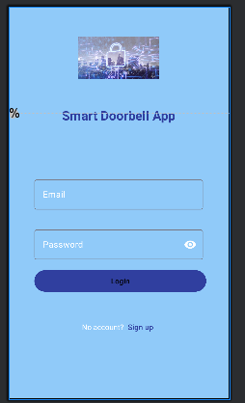
    - Figure 4f: User Login Page

    - App homepage
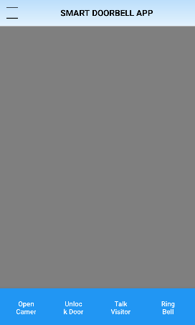
Figure 4h: home page

4.5.5. The user Registration form Page
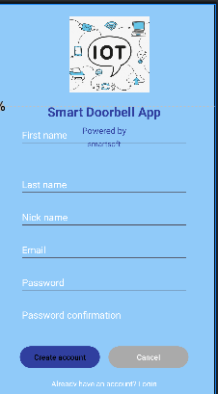
Figure 4i: The user Registration form Page

    - chat page
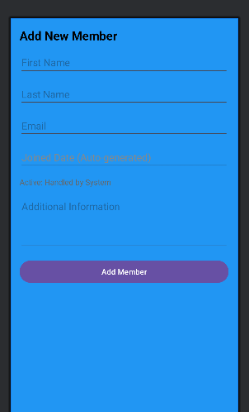
Figure 4j: chat Page

CHAPTER FIVE: SYSTEM CONSTRACTION

Introduction
Consists of all of the activities required to build and validate the new system to the point at which it can be turned over for System Acceptance. Development efforts in this phase are based on the technical solution created during System Design, which, in turn, was based on the functional and operational requirements captured during System Requirements Analysis.
Included in this phase is the construction of all components of the system, including utilities required to adequately prepare and load the data. In addition, System Construction consists of a series of tests of the system components, with each set of tests being performed against a progressively larger grouping of components until the operation of the system in its entirety has been verified

5.2. Users registration form
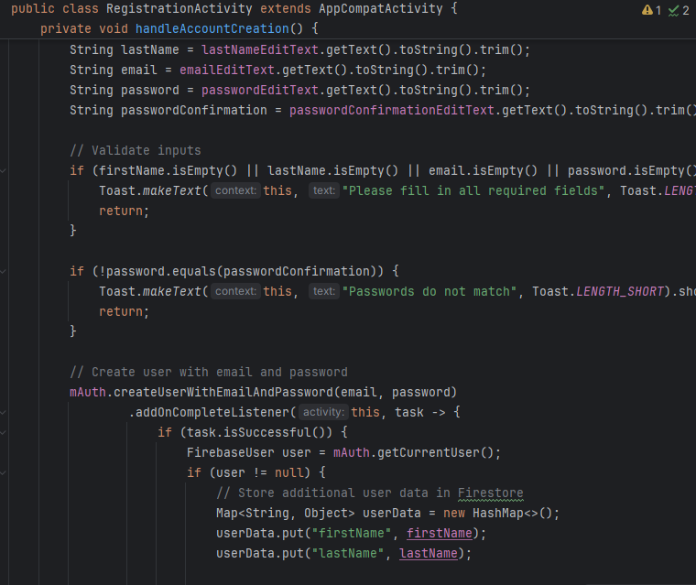

5.3 Login page for the user
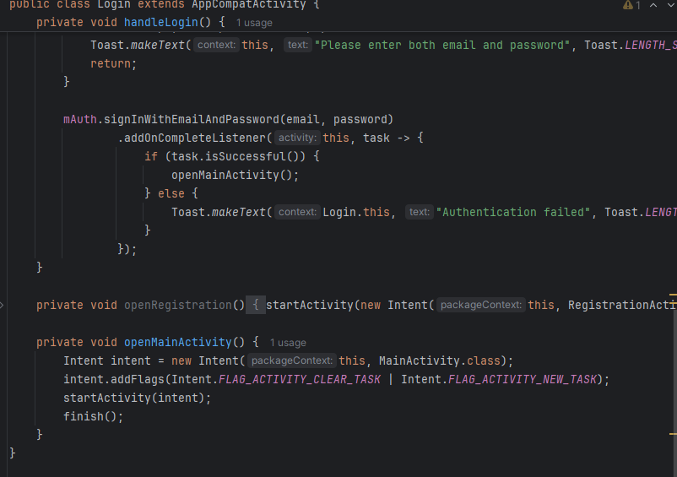

5.5 Home page
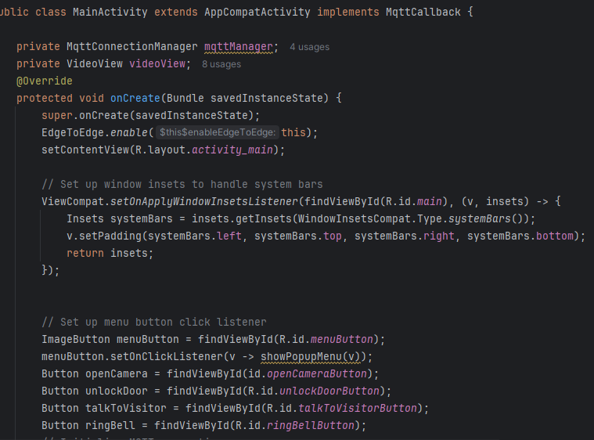

5.6 Wokwi simulation
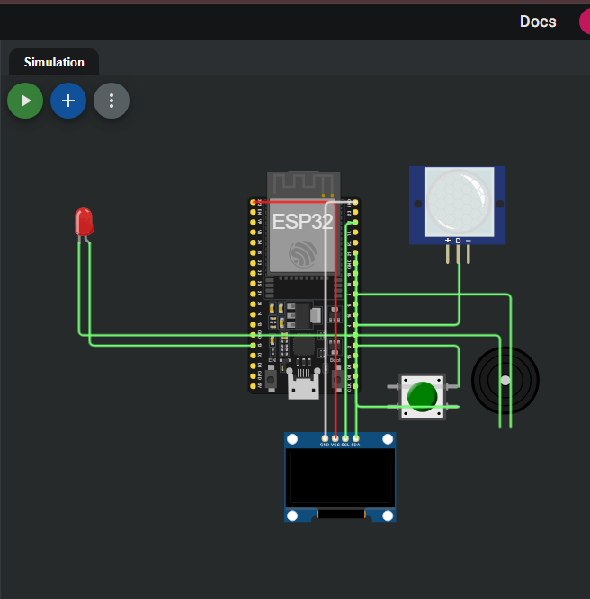

CHAPTER SIX: SYSTEM TESTING
6.1. INTRODUCTION
Functional Testing
Functional testing ensures the smart doorbell works as intended. Test cases include verifying doorbell press detection, live video streaming, two-way audio, motion alerts, and cloud storage. The mobile app controls, such as remote unlocking and settings customization, should also be validated. This testing confirms all features meet user requirements without errors.

Integration Testing
Integration testing checks interactions between hardware, firmware, cloud services, and the mobile app. Key tests include Bluetooth/Wi-Fi pairing, cloud API communication, third-party integrations (e.g., Alexa), and firmware updates. Ensuring seamless data flow between components prevents failures in real-world usage.

Usability Testing
Usability testing evaluates the user experience of the mobile app and doorbell interface. Testers assess app navigation, notification clarity, and accessibility features like voice commands. Feedback from real users helps improve intuitiveness, ensuring the system is easy to set up and operate.

Performance Testing
Performance testing measures system reliability under different conditions. Tests include network latency impact, load handling during peak usage, stress scenarios (e.g., firmware updates while streaming), and long-term stability checks. This ensures smooth operation even under heavy usage.

Security Testing
Security testing protects against vulnerabilities and unauthorized access. Tests include authentication checks, data encryption validation, penetration testing (e.g., MITM attacks), and physical tamper detection. Ensuring robust security prevents breaches and maintains user trust.6.2.1 Security Features Built-in in the System
The following security features were built into the system:
a) An individual not registered to vote is not able to cast a ballot.
b) A voter is not able to vote more than once.
c) Password authentication: This is another good security feature for checking all unauthorized attempts.
d) Password has been hashed (one-way encryption).
g) System also ensures that the username entered during registration is the school registration number that is active in the school ERP
h) System does not at any time show voter’s password in plaintext.

6.3 User Manual
Introduction
The Smart Doorbell Mobile App connects your smartphone to your IoT doorbell, enabling real-time monitoring, two-way communication, and instant alerts. Designed for both iOS and Android devices, this app transforms your phone into a powerful security tool, letting you see and speak with visitors from anywhere. Whether you're at home or away, you'll never miss a delivery or guest again with these intuitive controls at your fingertips.

Getting Started
Begin by downloading the app from your device's official app store. After installation, create your account using an email address or mobile number, then verify through the confirmation link or OTP code. To connect your doorbell, ensure it's powered on and in setup mode, then follow the in-app pairing instructions which will guide you through Wi-Fi configuration and QR code scanning. The app will confirm when your device is successfully connected and ready for use.

Core Features
The home screen displays your live feed button, event history log, and settings menu. When visitors press your doorbell or trigger motion sensors, you'll receive immediate push notifications - tap these to view live footage or initiate two-way conversations. The video interface includes microphone and speaker toggles, along with snapshot and recording functions for documentation. Customize motion detection sensitivity and designated activity zones to reduce false alerts from passing cars or animals.

Advanced Functionality
Enhance your experience by integrating with smart home systems like Alexa or Google Assistant for voice-controlled access. Share limited app access with family members through the user management settings while maintaining admin control. The app automatically notifies you about important firmware updates that improve performance and security - always install these promptly while keeping your doorbell connected to power and Wi-Fi.

Troubleshooting & Support
For common issues like connection drops or notification delays, first check your Wi-Fi signal and restart both app and doorbell. If live feed quality suffers, adjust your router settings or move the doorbell closer to your access point. Battery-powered models may need frequent charging if motion alerts are set to high sensitivity. Visit the in-app support section for detailed troubleshooting guides or to contact our customer service team for personalized assistance.

Security Recommendations
Protect your privacy by using strong, unique passwords and enabling two-factor authentication. Regularly review your event history and connected devices to spot any unauthorized access. The app employs end-to-end encryption for all video transmissions, but you should still keep your smartphone's operating system updated for maximum security. For optimal performance, maintain both app and doorbell firmware at their latest versions through automatic updates.
6.4 Conclusion
The Smart Doorbell Mobile App puts security and convenience in the palm of your hand, allowing you to monitor your doorstep in real time, communicate with visitors, and review past events with ease. By following this guide, you can maximize all the app’s features—from motion detection customization to smart home integrations—ensuring a seamless and secure experience.

Should you encounter any issues, refer to the troubleshooting tips or reach out to our support team for assistance. Keep your app and doorbell firmware updated to enjoy the latest enhancements and security protections.

6.5 Recommendations
To ensure the best performance and security from your IoT Smart Doorbell App, we recommend the following:

Regular Updates

Keep both the mobile app and doorbell firmware updated to access the latest features and security patches. Enable automatic updates when possible.

Strong Network Connection

Use a stable Wi-Fi network (preferably 2.4GHz for better range or 5GHz for faster speeds) to minimize lag in live feeds and notifications.

Battery Maintenance (If Applicable)

If your doorbell is battery-powered, monitor battery levels in the app and recharge as needed. Reduce motion sensitivity to extend battery life.

Privacy & Security Best Practices

Enable two-factor authentication (2FA) for your account.

Use a strong, unique password and avoid sharing login details.

Regularly review connected devices and event logs for suspicious activity.

Optimal Camera Placement

Position the doorbell at a height of 48-56 inches (1.2-1.4m) for the best facial recognition.

Ensure the lens is free from obstructions (e.g., direct sunlight, spider webs).

REFERNCES

CISCO Systems. (2022). IoT security best practices: Protecting connected devices. https://www.cisco.com/c/en/us/solutions/internet-of-things/iot-security-best-practices.html

National Institute of Standards and Technology (NIST). (2020). Guidelines for IoT device cybersecurity: Core baseline (Special Publication 800-213). U.S. Department of Commerce. https://doi.org/10.6028/NIST.SP.800-213

Zhang, L., & Li, X. (2021). Privacy concerns in smart home applications: A user perspective. Journal of Cybersecurity and Privacy, 1(3), 412–428. https://doi.org/10.3390/jcp1030022

APPENDICES
Appendix I: Project Schedule

Requirement Gathering and Analysis
10 days

30 days
Design
5 days
Testing

Implementation
5 days

Maintenance
5 days

55 days Documentation

Appendix II: Project Budget
Budget No | Items | Kshs
1. | Laptop PC (Asus X 453M, Intel Pentium, 4GB RAM,500 GB HDD) | 30,000
2. | Documenting the Project Proposal and Project Paper (Printing) | 1000
3. | Stationery [Pens, pencils, rough draft notebooks] | 500
4. | Computer storage devices such as Flash disk 16 GB, Hard Disk 500GB and CD ROMs | 500
5. | Modem and bundles | 10000
 | Total | 42000

